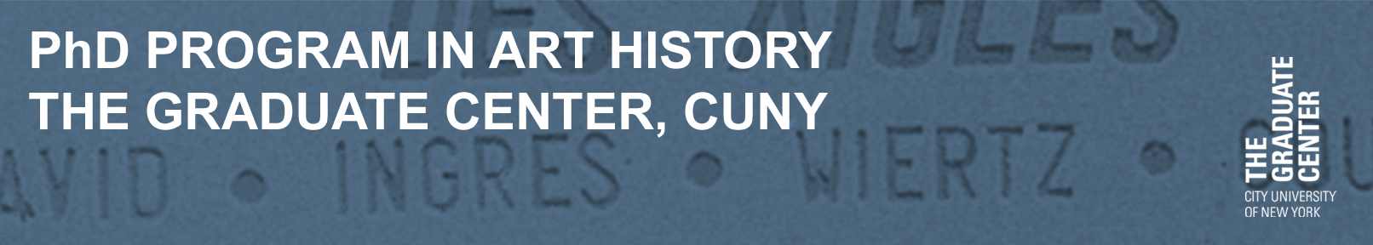
ALUMNI Newsletter 2016-2017
Dear Alums,
The 2016-17 academic year has been a busy one for faculty and students alike, with a diverse and very energetic new cohort of incoming students, along with four (!) student-organized symposia, a student-organized exhibition at the James Gallery, and thirteen dissertation defenses.
We welcomed our 2016 cohort of nine students this August and they have settled in nicely. They’ve formed a listserv, had a riotous new student dinner at Café China in December, and navigated the complex CUNY bureaucracy with aplomb. For more details, please see the introduction to them later in this newsletter. Currently we are finalizing our incoming class of 2017. We have an intriguing mix of students, with interests in everything from medieval French reliquaries to 19th century dress and Puerto Rican women’s art collectives of the 1970s. Stay tuned for our student profiles of them in next year’s alumni newsletter.
Another important new arrival this year has been our new Assistant Program Officer, Marilyn Mercado. With her previous experience in the GC’s Classics department, combined with a great love of art (favorite painter: Caravaggio), she has adapted well to her new environment. I particularly appreciate her calm, even temperament and ability to figure out how to do anything (well, almost anything!) within the confines of CUNY’s sometimes arcane bureaucratic systems. If you haven’t stopped by yet, please introduce yourself; she has excellent advice on all matters CUNY, and also on English literature, with a particular penchant for the short story (in her spare time, she teaches English enrichment classes to middle-schoolers in the Bronx).
Our students have had a busy year — I know, I always say that, but this year, even more so! With our Rewald Endowment, we’ve been able to host four student-organized conferences in 2016-17. The first, “Scales of Visibility in Global Indigenous Art,” was put together by Chris Green, Joseph Henry, and Ian Wallace, with Professor David Joselit as adviser; it examined issues of indigeneity and globalism, and was recognized as one of the Top Ten Native Art events of 2016 by First American Art Magazine. This spring began with a March conference, “Art, Institutions, and Internationalism: 1933-1966,” initiated by Chelsea Haines and Gemma Sharpe, with Professor Romy Golan as adviser. Co-organized with MoMA’s Contemporary and Modern Art Perspectives (C-MAP) program, it included two days of papers, workshops, and conversations with curators on questions surrounding the shifting stakes and definitions of internationalism in the period just before, during, and after World War II.
April brought another conference, “American Identities on Land and at Sea,” co-organized by students Eva McGraw and Bree Lehman, alumna Shannon Vittoria, and Professor Katherine Manthorne; this symposium offered an innovative new look at continental and transatlantic interconnections as manifest in American art (as well as an exciting preview up the upcoming Thomas Cole exhibition at the Metropolitan Museum of Art that Shannon is working on!). And I just this month attended, “In Black and White: Photography, Race, and the Modern Impulse in Brazil at Midcentury,” co-organized by Abigail Lapin Dardashti and MoMA curator Sarah Hermanson Meister. These four wide-ranging and ambitious conferences brought home to me, once again, just how much our students are contributing to the development of the field as a whole; stay tuned next fall for our upcoming conference, “Revolution in the Margins, 1917-2017: Modern and Contemporary Art from Eastern, Central, and South Eastern Europe,” co-organized by Alise Tifentale, Patryk Tomaszewski, and Rachel Wetzler, with faculty advisers Romy Golan and Katherine Carl.
We’re also very proud of our latest student-curated exhibition at the James Gallery, Kaegan Sparks’s “Soft Skills,” which pairs artworks from the 1970s with contemporary practices to show how role-play and self-management function both as feminist performative strategies and imperatives of post-Fordist labor. The show runs from Friday, April 14th-Saturday, June 3rd; please do come and check it out!
For announcements about these events, and many others, you can follow not only our listserv, but also our Facebook page https://www.facebook.com/GCArtHistory/, our Twitter account (@GCArtHistory), and our Instagram feed (@GCArtHistory). Please follow us, and send updates on your doings to gcarthistoryalumni@gmail.com.
Over the course of the 2016-17 academic year, our students have completed thirteen dissertations, on topics ranging from nineteenth century Italian photography to the architecture of urban renewal in New York, Ludic Conceptualism in the Netherlands, and the French Rococo. We’re going to miss them, but are proud of their accomplishments and of the exciting positions they have landed, from the J. Paul Getty Museum to Portland State University.
We’re also extremely proud of the banner year we’ve been having in external fellowships. Winners have included three Fulbrights on three different continents (Chelsea Haines, Israel; Stephanie Huber, the Netherlands; Abigail Lapin Dardashti, Brazil), as well as an American Council of Learned Societies/Luce Dissertation Completion Fellowships (Saisha Grayson), a Mellon-Council of European Studies Dissertation Completion Fellowship (Paula Burleigh), and a Research Fellowship from the Consortium for the History of Science, Technology and Medicine (who would have guessed an art historian could get this? The lucky winner was Lauren Rosati). We’ve been working hard to ensure that our students are competing for external grants, and we’re thrilled to see our efforts bearing fruit.
Another central focus of effort this year has been alumni outreach. Many thanks to all of you who filled out our alumni survey and attended our alumni breakfast at CAA (next year’s is Thursday, Feb. 22nd, in Los Angeles – mark your calendars!). We also hosted our first-ever alumni/faculty/student book party this May. With books on everything from Bruce Connor to Baroque Seville, it showcased the diversity of interests within our program.
A special thanks to those who have volunteered to serve as mentors in academic, curatorial, and ‘alt-ac’ careers. We’ve now matched all students who requested them with alumni mentors; it’s a great opportunity for students to think through career options, and get real-world advice, while still in school. If you are interested in volunteering but haven’t contacted us yet, please feel free to let us know via email at arthistory@gc.cuny.edu. You have so much to give, in terms of wisdom and experience; we really appreciate it.
Finally, please consider making a donation to support the program’s activities. Particularly in the current funding climate, with widespread cuts to public higher education, your assistance makes a difference in supporting needy students; any amount is welcome.
Sincerely,
Rachel Kousser,
Executive Officer
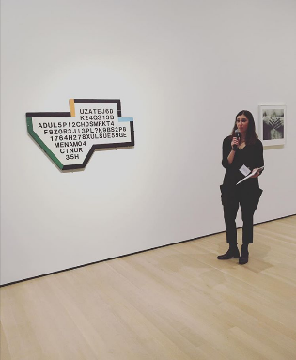
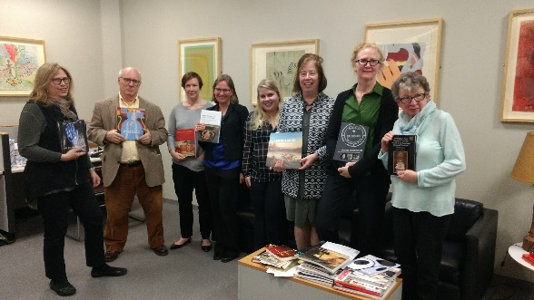
Left Top: Rachel Valinsky presenting Guy de Cointet's Going to the Market (1978) at the MoMA Research Consortium, March 2017. Bottom: Jack Crawford presenting Lynda Benglis' Now (1973) at the MoMA Research Consortium, March 2017.

Right Top: Art History Program Book Party, May 2017, (left to right): Prof. Cynthia Hahn, John Cauman (alum), Prof. Amanda Wunder, Prof. Rachel Kousser, Anna Ficek, Prof. Kathie Manthorne, Anastasia Aukeman (alum), and Sally Webster (alum). Bottom: CAA Alumni Breakfast, February 2017.

Below: CAA Presenters Dinner (left to right): Alise Tifentale, Michelle
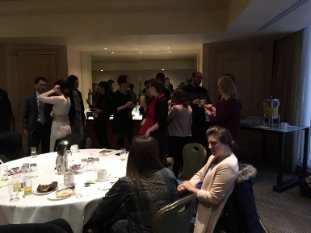
Millar Fisher, Saisha Grayson, Andrew Capetta, Chelsea Haines,
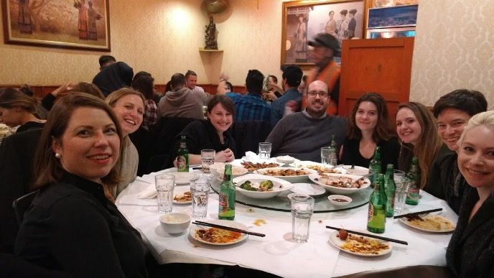
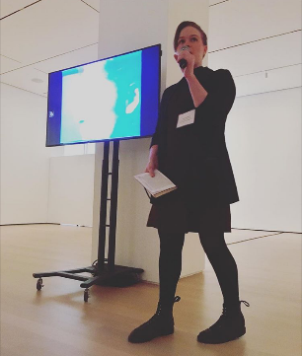
Amanda Wasielewski, Mya Dosch, and Meredith Mowder

DEPARTMENT NEWS
DEPARTMENT WELCOMES NEW STUDENTS  The department congratulates our newest cohort of  students who began their studies at the GC this fall:  Tobah Aukland-Peck (B.A., Wesleyan University);  Mia Curran (B.A., Georgetown University); Anna Ficek (M.A., Hunter College); Jessica Fletcher (M.A., Columbia University); Aubrey Knox (M.A., Columbia University); Jessica Larson (M.A., Delaware University); Mary Potter (B.A., Harvard University); Horacio Ramos (M.A., Pontificia Universidad Católica del Perú); Patryk Tomaszewski (M.A., Institute of Fine Arts, New York University) |  | ART HISTORY STUDENTS RECEIVE MELLON GRANTS  The following students have received Mellon funded internships as part of the department’s grant from the foundation:  2015 – 2016: Matilde Guidelli Guidi (Dia Art Foundation), Nadiah Fellah (Newark Museum), Lauren Rosati (Whitney Museum)  2016-2017: Liz Hirsch (Dia Art Foundation), Chloe Wyma (Queens Museum), Matilde Guidelli Guidi (Whitney Museum), Kaegan Sparks (James Gallery)  2017-2018: Kaegan Sparks (Dia Foundation), Horacio Ramos (El Museo del Barrio), Ana Perry (Whitney Museum)
Student Organized Exhibition at the James Gallery

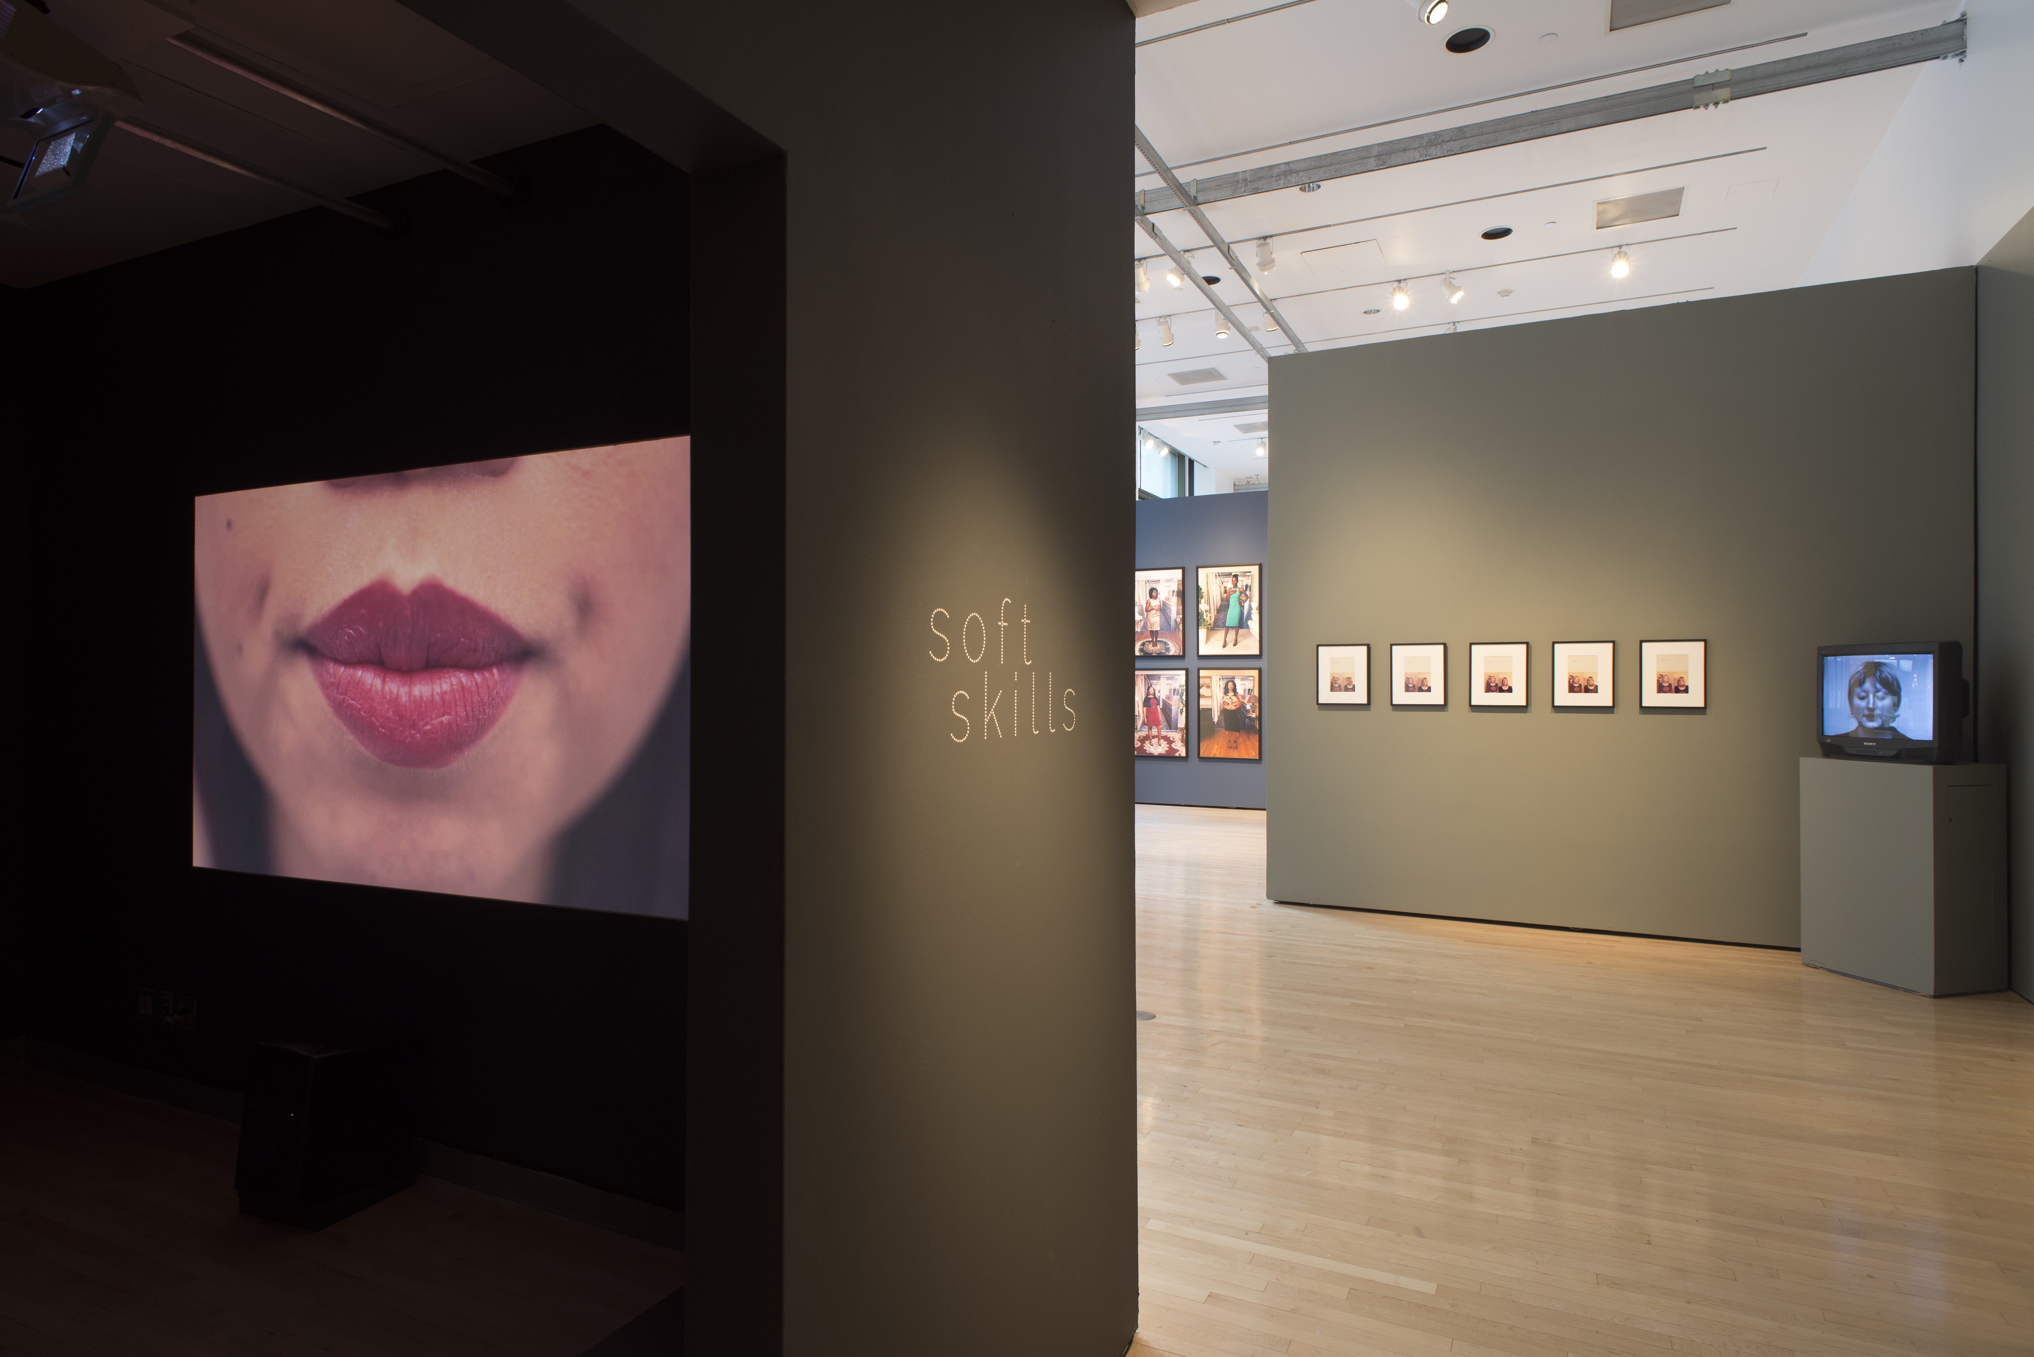Pairing artworks from the 1970s with contemporary practices, "Soft Skills" (April 15–June 3, 2017) organized by Ph.D. student and James Gallery Mellon Curatorial Fellow, Kaegan Sparks, critically examines interpersonal capacities like communication, cooperation, empathy, and flexibility, framing them as modes of feminized performance—and moreover, as work. Early feminist art often troubled the threshold between artifice and authenticity, using devices like masquerade and fictive personae to denaturalize the relationship between subjectivity and gender. This exhibition draws parallels from that groundbreaking work to more recent art from the U.S. and Canada, historicizing their connection in light of the transformation of labor practices in those countries over the past four decades. Together, the works demonstrate role-play and self-management as both feminist performative strategies and imperatives of post-Fordist labor. "Soft Skills" is on view until June 3, 2017.
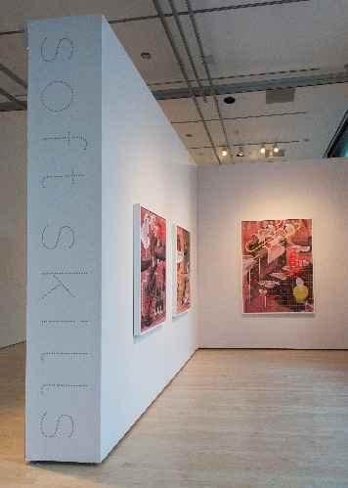
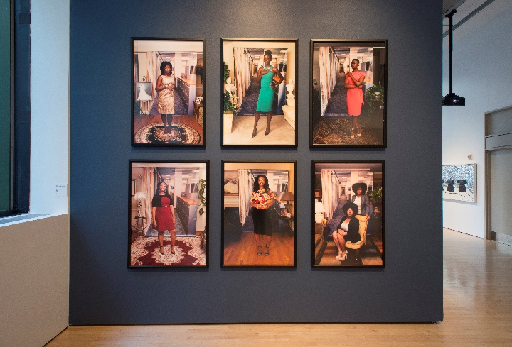
Participating artists include Eleanor Antin, Endia Beal, Tasha Bjelić, Danielle Dean, Heather Keung, Barbara Kruger, Suzy Lake, Jen Liu, Martha Rosler, Emily Shanahan, Frances Stark, and Martha Wilson.

"Soft Skills" was selected as an Artforum Critics’ Pick in mid-May.

Image Credits: “Soft Skills" installation views, The James Gallery, The Graduate Center, CUNY. All Photos by Samuel Draxler.
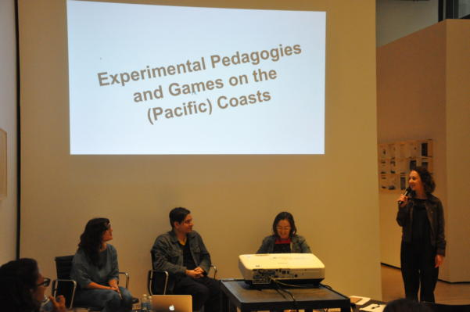
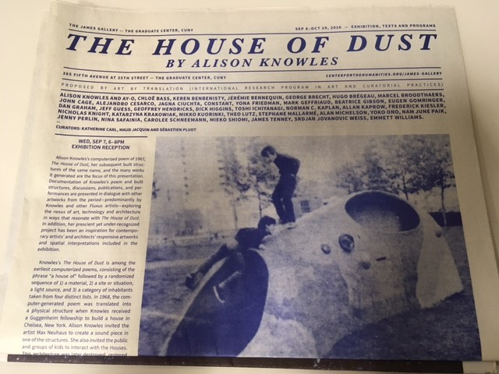
STUDENTS CONTRIBUTE TO JAMES GALLERY EXHIBITION
“The House of Dust by Alison Knowles” Exhibition Publication.
In the fall semester, art history students contributed to the exhibition publication and participated in the public programming of the James Gallery’s exhibition "The House of Dust by Alison Knowles," (Sept. 7, 2016 – Oct. 29, 2016), curated by Katherine Carl, Maud Jacquin, and Sébastien Pluot.
Contributions to the exhibition publication included:
- Chris Green, "A House of Dust ... Inhabited by American Indians"
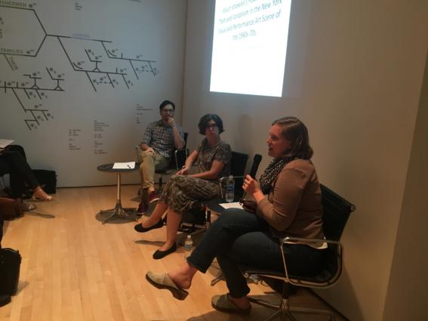
- Debra Lennard, "A Chronology of Early Digital Poetics"
- Hallie Scott, "The House of Pedagogy"
- Gillian Sneed, "Play Sculptures and Public Art: Alison Knowles' The House of Dust and the Failure of Community Engagement"
- Ian Wallace, "Stop Making Sense: House of Dust and the Aesthetics of Techno-Utopianism"
Public programming participation included:
- Hallie Scott and Liz Donato organized “Pedagogy and Games on the (Pacific) Coasts,” Sept. 2016
- Rachel Valinksy organized and Ian Wallace participated in “From House of Dust to Antitrust,” Sept. 2016
- Kaegan Sparks introduced Soyoung Yoon’s "Is it alive, is it real?" Sept. 2016
- Rachel Valinsky introduced “Flux-Homes for America: Architecture, Publication, Intermedia,” Oct. 2016
- Gillian Sneed participated in “Cleaning Up New York City in the 1960s and 1970s,” Oct. 2016

Above: (left to right): Hallie Scott, Felipe Mujica (Galería Chilena), Liz Donato, and Jennifer Wilkinson (James Gallery) at “Pedagogy and Games on the (Pacific) Coasts.” Photo courtesy the James Gallery.
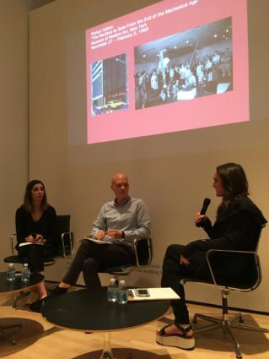
Right: (left to right): Rachel Valinsky, Ian Wallace, and Lucy Hunter (Yale) in conversation at "From House of Dust to Antitrust."

Below: (left to right): Aleksei Grinenko (Theatre), Prof. Elizabeth Wollman (Theatre), and Gillian Sneed at "Cleaning Up New York City in the 1960s and 1970s."
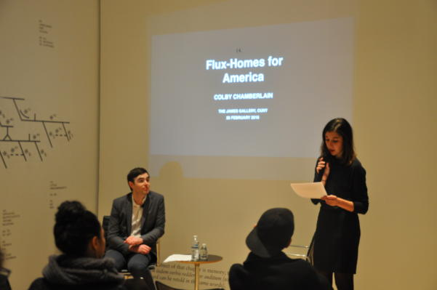
Above: Rachel Valinsky introducing Colby Chamberlain (Columbia University) at “Flux-Homes for America: Architecture, Publication, Intermedia.” All Photos courtesy the James Gallery.
RECENT STUDENT ORGANIZED CONFERENCES  “Scales of Visibility in Global Indigenous Art” Organized by Christopher Green, Joseph Henry, and Ian Wallace with faculty adviser David Joselit, October 14, 2016  This conference convened scholars, artists, and curators to explore how the commodification and visibility of ethnic difference increasingly plays a role in the globalized world of contemporary art. The keynote performative lecture was given by the artist James Luna, and the conference was followed with a performance by Maria Hupfield (Anishinaabe), responding to the James Gallery's “Allison Knowles: The House of Dust” exhibition. The conference was convened in conjunction with the Indigenous New York program the following day at the Vera List Center.  “Art, Institutions, and Internationalism: 1933–1966”  Organized by Chelsea Haines and Gemma Sharpe with faculty adviser Romy Golan, March 7-8, 2017  This two-day conference (co-organized with the Center for the Humanities and C-MAP at MoMA) explored exchange of art and ideas among nations during the transition from colonial to post-colonial statehood in Africa, Asia, and the Middle East. Speakers included Graduate Center faculty Claire Bishop, Katherine Carl, Romy Golan, David Joselit, and Antonella Pelizzari; PhD candidates Alise Tifentale and Abigail Lapin Dardashti; and alumnus Nikolas Drosos. Additional speakers included Lucia Allais, Olga Herrera, Naeem Mohaiemen, Chika Okeke Agulu, Katy Siegel, Sarah-Neel Smith, Yang Wang, and more.  “American Identities on Land and at Sea” Organized by Eva McGraw, Shannon Vittoria, and Bree Lehman, with faculty adviser Katherine Manthorne, April 21, 2017  Featuring papers by both established and emerging scholars, the conference explored how reinterpretations of American landscapes and seascapes from the eighteenth to twenty-first centuries can challenge, subvert, and transform traditional conceptions of American identity. | “In Black and White: Photography, Race, and the Modern Impulse in Brazil at Midcentury” Organized by Abigail Lapin Dardashti, Nadiah Fellah, and MoMA Curator Sarah Meister, May 2-3, 2017.  This initiative investigated Brazilian modernist photography, its relationship to race, and its place within a dynamic international network of images and ideas. From experimental work that resonates with broader postwar trends of creative photographic expression to modern forms with local and sometimes ethnic inflections, photographers were instrumental in formulating new visual languages in Brazil. The conference stretched the boundaries of what we understand as experimental art in Brazil in the mid-twentieth century. Participants brought an international perspective to the conference, investigating networks of modernist photography through transnational photo clubs, salons, exhibitions, and the many magazines that flourished domestically and across Latin America, the United States and Europe.  UPCOMING STUDENT ORGANIZED CONFERENCES  “Revolution in the Margins, 1917-2017: Graduate Student Conference on Modern and Contemporary Art from Eastern, Central, and South Eastern Europe” Organized by Patryk Tomaszewski, Rachel Wetzler, and Alise Tifentale, Oct. 13, 2017  This conference proposes the centennial of the 1917 Russian Revolution as an opportunity to re-examine the last century of artistic production in the countries of Eastern, Central, and Southeastern Europe. While acknowledging the significant role of the Soviet Union as both a political superpower and an arbiter of cultural policy in the region, a central aim of this conference is to nuance the picture of art in the region by “provincializing” Russia and challenging the common perception that Eastern European art can be entirely equated with Soviet politics and aesthetics.
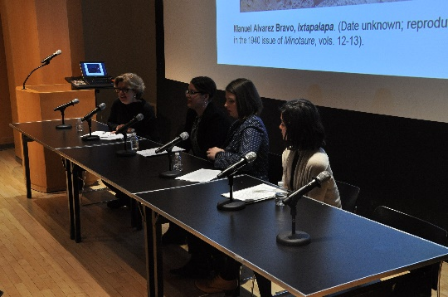
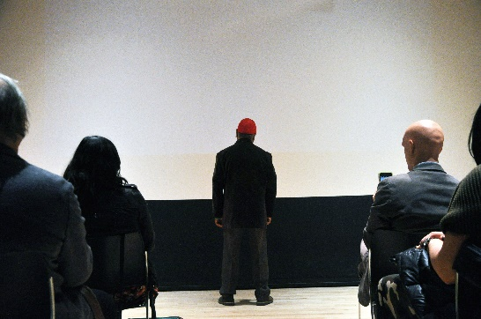
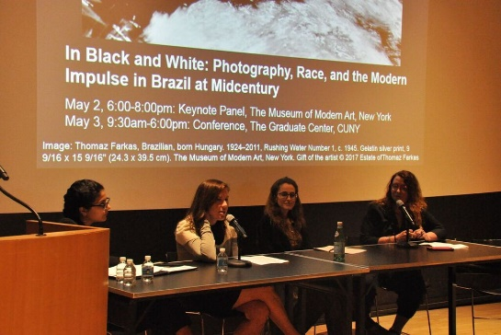
Left: (left to right): Monica Bravo (Yale University), Danielle Stewart, Abigail Lapin Dardashti, and Prof. Anna Indych-Lopez speaking at “In Black and White: Photography, Race, and the Modern Impulse in Brazil at Midcentury,” May 2017.
Middle: James Luna (Pooyoukitchum [Luiseño]) performs an untitled lecture ("Make America Red Again") at “Scales of Visibility in Global Indigenous Art,” Oct. 2016.
Right: (left to right): Prof. Antonella Pelizzarri, Maxine Anderson (University of Oregon), Alise Tifentale, and Naomi Kuromiya (NYU) at “Art, Institutions, and Internationalism: 1933–1966,” March 2017. All Photos by Alisa Besher, courtesy Center for the Humanities.

EXTERNAL AWARDS  American Association for Netherlandic Studies Scholarship: Stephanie Huber (2017-18)  Andrew W. Mellon Foundation Predoctoral Fellowship in Women’s History, New York Historical Society: Will Simmons (2017)  Auschwitz Jewish Center Fellowship: Rebecca Pollack (2016)  Avery Arts Foundation Curatorial Fellowship: Luisa Valle (2017-18)  Barra Fellowship, Philadelphia Museum of Art: Betsy Hawley (2017)  Center for Curatorial Leadership Seminar: Lee Hallman (2016)  Consortium for the History of Science, Technology and Medicine Research Fellowship: Lauren Rosati (2017-18)  Decorative Arts Trust Summer Research Grant: Sarah Mills (2016)  Fullbright U.S. Student Program: Abigail Lapin Dardashti (Brazil); Chelsea Haines (Israel); Stephanie Huber (the Netherlands) (2017-18)  Getty Research Institute Library Grant: Ian Wallace and Amanda Wasielewski (both 2016)  IDRF Social Science Research Council: Abigail Lapin Dardashti, and Amanda Wasielewski (2017-18)  Joan Stanford Alexander Award, MFAH: Leila Harris (2017)  Luce Dissertation Completion Fellowship: Saisha Grayson (2017-18)  Mellon Council of European Studies Dissertation Completion Fellowship: Paula Burleigh (2017-18)  Mid-Atlantic Popular and American Culture Association, Ralph Donald Award: Meredith Mowder (2017)  Midwest Art History Society Graduate Student Distinguished Presentation Award: Chris Green (2016) | Paul Mellon Centre Junior Fellowship: Leila Harris (2017)  P.E.O. Scholar Award: Michelle Millar Fisher (2017-18)  Walter Read Hovey Scholarship: Betsy Hawley (2017-18)  INTERNAL AWARDS  CUNY-NY Botanical Garden-Humanities Institute Research Fellowship: Leila Harris (2017)  Doctoral Student Research Grants: Chris Green, Joseph Henry, Nadiah Fellah, Rebecca Pollack (2017)  Early Research Initiative Awards: Liz Hirsch, Nadiah Fellah, Maya Harakawa, Chris Green, Caroline Gillaspie, and Eva Gratta (Knickerbocker Awards for Archival Research in American Studies); Dana Liljegren (Award for Archival Research in African American and African Diaspora Studies) (2017)  Graduate Center Dissertation Fellowships: Liz Donato (Altman Award); Gillian Sneed (Capelloni Award) (2017-18)  Graduate Center Dissertation Year Awards: Betsey Hawley; Alise Tifentale (2017-18)  Inter-University Program for Latino Research/ Mellon Fellowship: Nadiah Fellah (2017-18)  Level III Tuition Fellowships: Alice Walkiewicz (Alumni Tuition Fellowship); Sarah Mills (Tuition Fellowship) (2017-18)  Lost & Found Archival Research Grant: Siwin Lo (2016)  Mellon Humanities Alliance Graduate Fellowship: Patryk Tomaszewski (2017-18)  Presidential Research Fellowship: Patryk Tomaszewski (2017)  Provost’s Pre-Dissertation Award: Anna Ficek, Rebecca Pollack (2017)
The College Art Association (CAA) Conference
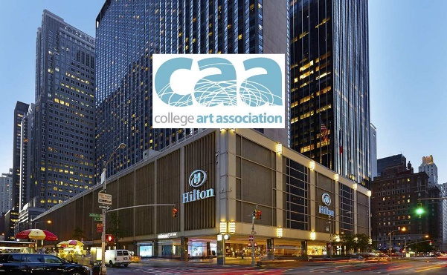
CAA session chair Professor Katherine Manthorne as well as many Graduate Center faculty and students presented at the CAA meeting in New York City, held from February 15-18, 2017 , including program faculty: Molly Aitken, Mona Hadler, Cynthia Hahn, David Joselit, Gail Levin, and Amanda Wunder; as well our 15 doctoral candidates who spoke or chaired panels, including: Paula Burleigh, Andrew Cappetta, Sooran Choi, Mya Dosch, Arnaud Gerspacher, Saisha Grayson, Chelsea Haines, Michelle Millar Fisher, Meredith Mowder, Gillian Pistell, Lauren Rosati, Gillian Sneed, Sydney Stutterheim, Alise Tifentale, and Amanda Wasielewski.
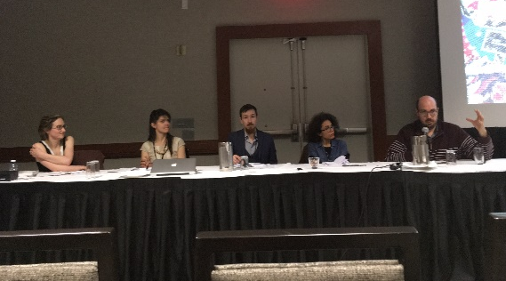
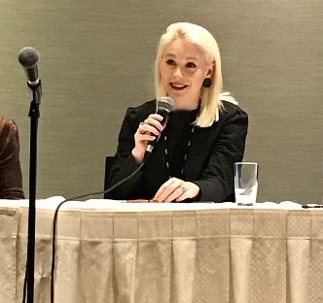
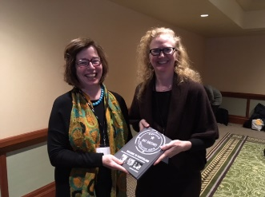
Left: Ph.D. Candidate, Meredith Mowder speaking on the panel “Immeasurable Extravagance: Proposals for an Economy of Abundance in an Age of Scarcity” Center: Ph.D. Candidate, Andrew Cappetta (far right), Session Respondent on the panel “Seth Siegelaub and the Expanded Archive of Conceptual Art" Right: Alumna, Dr. Anastasia Aukeman and Prof. Katherine Manthorne at the CAA Alumni breakfast

FACULTY ACCOMPLISHMENTS

Professor Jennifer Ball wrote an essay, “Saint Sabas and the Monks of the Holy Land,” for the catalogue Jerusalem in the Middle Ages, which opened at the Metropolitan Museum of Art in September 2016. She also published, “The Lincoln Typikon: Group Identity and Social Structure in a Fourteenth-Century Convent” in The Journal of Medieval Monastic Studies this year. At their annual conference in October 2016, she was elected Vice President of the Byzantine Studies Association of North America.

Professor Claire Bishop won an Andy Warhol Foundation Arts Writers Grant for her next book project OS XXI: Contemporary Art and Attention in the Twenty-first Century and will be a faculty fellow at the GC’s Futures Initiative in fall this year. She has also won a fellowship at NYU’s Center for Ballet and the Arts (for spring 2018) and a Rauschenberg Residency at Captiva, FL (summer 2018).

Professor Romy Golan published “Realisms as International Style” (co-authored with Nikolas Drosos) for Postwar: Art between the Pacific and the Atlantic, 1945-1965 at the Haus der Kunst, Munich, 2016; «Temporalités cachées dans Campo Urbano, Côme, 1969,» Transbordeur: photographie histoire société, no. 1 (2017); and “Jannis Kounnelis,”Artforum (March 2017). Her lectures were: “Lets talk a bit about exhibitions,” The Cover-Up: Contribution to a Political Iconography at the Deutsches Haus, NYU; “In Moscow’s Orbit,” Bezalel Academy of Art, MFA, Tel Aviv, 2016; “Magic Realism Redux: Pistoletto and Casorati,” Post-It: Reconsidering the Postmodern in Italian Art and Performance since 1965 at CIMA, NY; “Gesta Curatoriali,” Spazio Elastico; “Critica, Esposizioni, Museo,” MAXXI, Rome; and “The Troubled Dreams of Italian Art, 1960-1970,” Boston University.

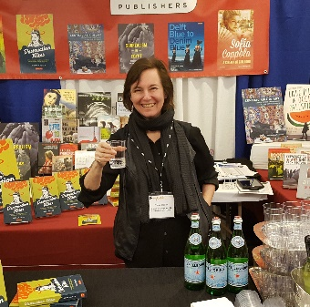
Professor Mona Hadler published Destruction Rites: Ephemerality and Destruction in Postwar Visual Culture ﻿by I.B. Tauris in 2017.

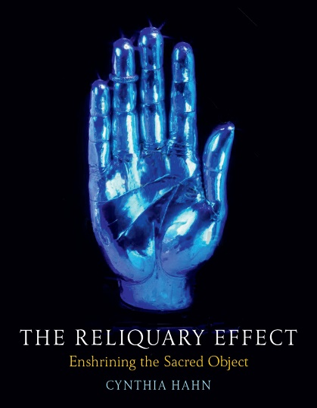
Professor Cynthia Hahn’s book The Reliquary Effect was just published by Reaktion press. Next year she will be on leave with a membership at the Institute for Advanced Study in Princeton. In April she lectured in Conques, France for the international group, Migrating Art Historians, and in May she co-chaired a conference in Florence on rock crystal. She recently appeared in Morgan Freeman's “Story of God” on the National Geographic channel in an episode filmed in Ethiopia.

Professor Anna Indych-López contributed to the catalogue of Paint the Revolution: Mexican Modernism, 1910-1950, the first major exhibition of Mexican art presented in the United States in over seven decades and organized by the Philadelphia Museum of Art and the Palacio de Bellas Artes, Mexico City. She also participated in the Association for Latin American Art’s Fourth Triennial at the De Young Museum in San Francisco in March 2016. Her paper “Judith Baca’s The Great Wall of Los Angeles: A Public Art of Contestation,” included material from her book on Baca for the “A Ver” series on Latinx artists (UCLA Chicano Studies Research Center and the University of Minnesota Press, Fall 2017).
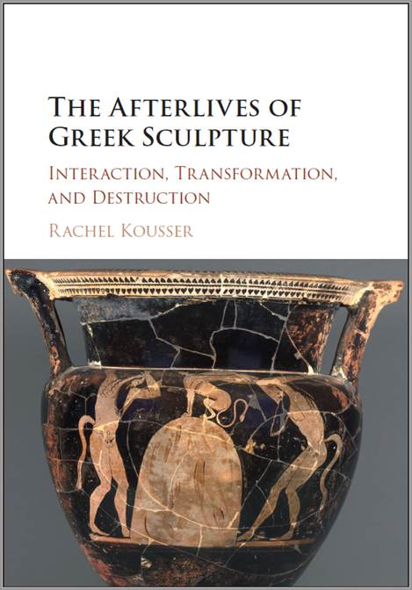
Professor Rachel Kousser had her book, The Afterlives of Greek Sculpture: Interaction, Transformation, Destruction, published by Cambridge University Press in January 2017. She gave talks at the University of Pennsylvania in the fall (the materiality of sculpture in Ptolemaic Egypt) and at the University of Kansas in the spring (Greek art and ritual).

Professor Judy Sund’s essay “Why So Sad? Watteau’s Pierrots,” inspired by the Getty’s purchase, in 2012, of Watteau’s Italian Comedians, was published in The Art Bulletin in September 2016. Meantime, Prof. Sund continues work on her book on exoticism in Western art (under contract to Phaidon), which is scheduled for publication next year.
Professor Gail Levin held a Distinguished Fulbright Chair, College of Fine Arts, Thiruvananthapuram, Kerala, India, October 2015-January 2016. She published her first book of fiction: “The Preacher Collects,” in Lawrence Block, ed. In Sunlight or In Shadow: Stories Inspired by the Paintings of Edward Hopper (New York and London: Pegasus Books, 2016). She served as guest curator and catalogue author for “Connie Fox and William King: An Artist Couple,” an exhibition at the Guild Hall Museum in East Hampton, NY. Publications include: Diana Copperwhite: Fake New World (Royal Hibernian Society, Dublin); “Sajitha: Journey in Art,” in Alter bodies: Sajitha R. Shankar (Alliance Française, Trivandrum, Kerala, India); “Threading Jewish Identity: The Sara Stern in Sonia Delaunay,”in Journal of Modern Jewish Studies, volume 15, no. 1; “Theresa Bernstein (1890–2002): A Krakow-born Jewish Artist in America,” in Art in Jewish Society, Warsaw, Poland; “Ángel Mateo Charris,” in Los Cosmolocalistas: Charris, MURAM (Museo Regional de Arte Moderno), Cartagena, Spain; “Syd Solomon,” "Syd Solomon: Concealed and Revealed"; “Linda Stein’s Holocaust Heroes: Fierce Heroes: Fierce Females and Related Works,” in Holocaust Heroes: Fierce Females: Tapestries and Sculpture By Linda Stein, New York: Have Art: Will Travel! Inc., “Gadfly of the Art World,” book review of Robert Hughes, The Skeptical of Skill, August 18, East Hampton Star; “Pousette-Dart’s Light: Recollections at the 100th Anniversary of His Birth,“ September 22, East Hampton Star; “The International Film Festival of Kerala,” ArtTimes, (Spring).
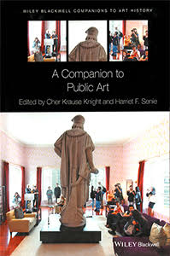
Professor Harriet F. Senie recently co-edited and contributed to A Companion to Public Art (Wiley Blackwell, 2016). Her book, Memorials to Shattered Myths (Oxford University Press, 2016) was named an outstanding book in the arts and humanities by the American Library Association in 2016 and selected by the Truthout magazine’s ‘Progressive Picks’ for its thought-provoking and insightful content. Professor Senie published articles for the Truthout and History News Network in 2016 discussing the memorialization process of terrorist attacks including the Columbine shooting. Professor Senie continues to contribute to the Psychology Today blog discussing public art within the contemporary political milieu.

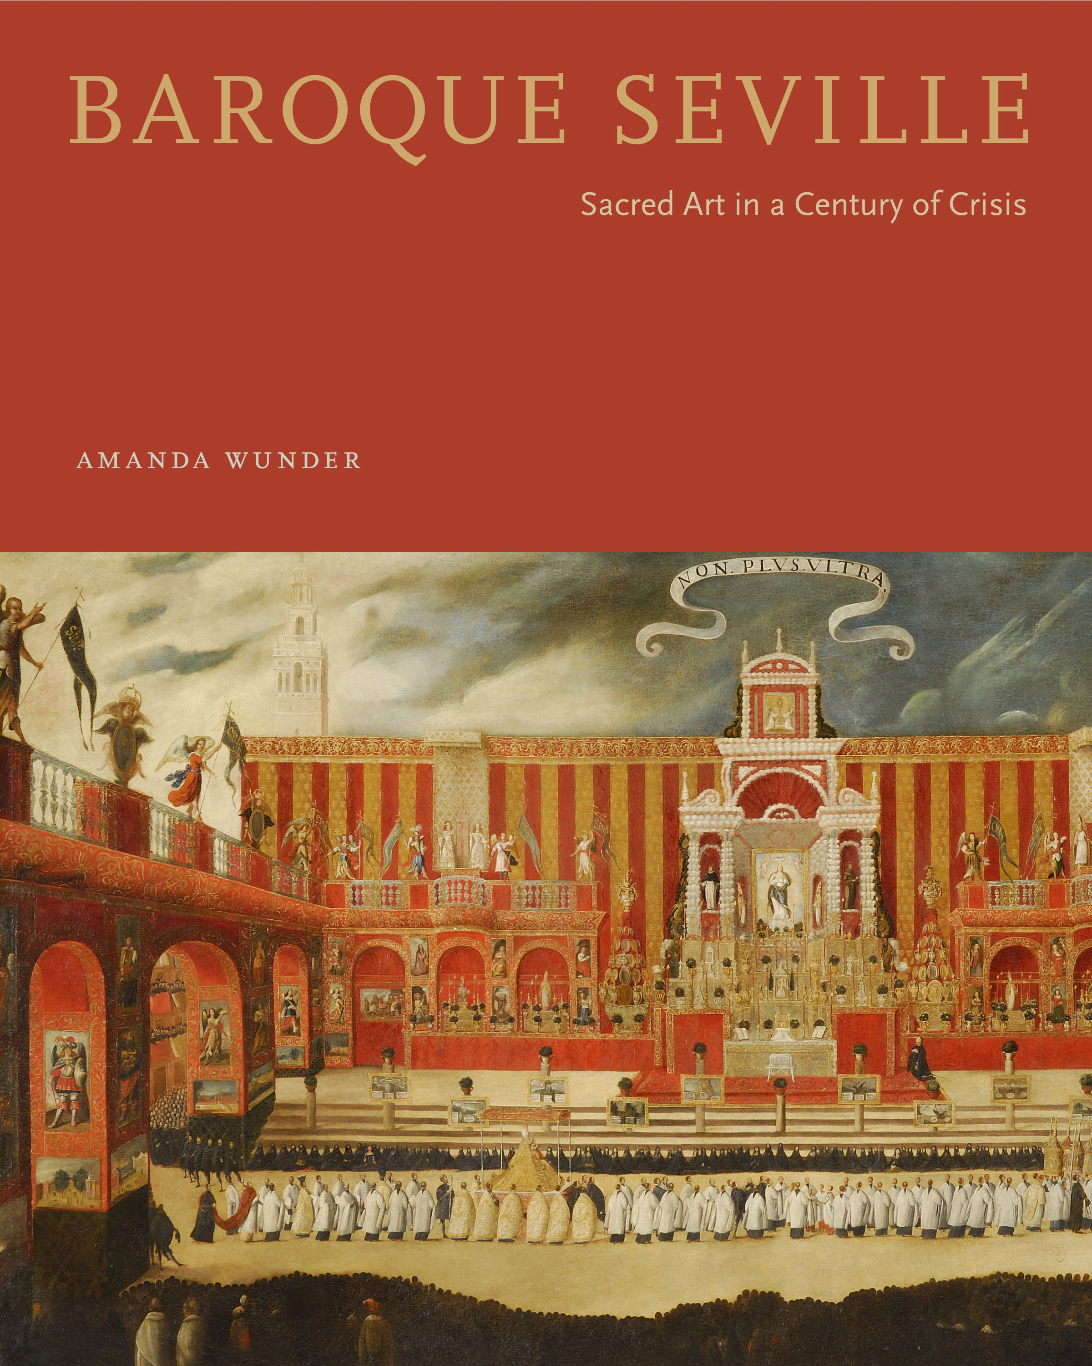Professor Amanda Wunder published Baroque Seville: Sacred Art in a Century of Crisis (Penn State Press, 2017) with a subvention awarded by CAA’s Millard Meiss Publication Fund. This spring she presented her book at a Rewald Seminar and in a public lecture at the IFA’s Roberta and Richard Huber Colloquium on the Arts and Visual Culture of Spain and the Colonial Americas. In 2017-18 she will be on sabbatical and working on a new book about controversial fashions and gender politics in seventeenth-century Spain with a research fellowship at the Bard Graduate Center.

Professor Katherine Manthorne’s essay “Art School as Inter-American Contact Zone” appeared in The Routledge Companion to Inter-American Studies (2017). Her exhibition California Mexicana: Missions to Murals, 1820-1930 – part of Getty’s PST2 – opens at Laguna Art Museum in October 2017 (book from University of California Press with contributions from Grad Center students). Her exhibit The Rockies and the Alps: Bierstadt, Calame, and the Romance of the Mountains—co-curated with Tricia Bloom—opens at Newark Art Museum in March 2018 (book from Giles, Ltd.) She contracted with Routledge for her forthcoming book Film and Modern American Art: The Dialogue between Cinema and Painting.

Professor Emily Braun received two awards for her book, Alberto Burri: The Trauma of Painting: The Dedalus Foundation Exhibition Catalogue Award; and Honorable Mention (Second Place) for Best Catalogue, the Association of Art Museum Curators (AAMC) (both in 2016). As a contributing author to The Steins Collect: Matisse, Picasso and the Parisian Avant-Garde. she was also a co-recipient of the 2016 Frick Museum Center for the History of Collecting, Biennial Prize for a Distinguished Publication on the History of Collecting. Published essays include: “Shadows, Shading and Shades,” in Harry Cooper ed. Cubism: CASVA Seminar Papers 3: (Washington DC: National Gallery of Art, 2017); “The Dirt Paradigm,” in Okwui Enwezor, Katy Siegel and Ulrich Wilmes eds. Postwar: Art Between the Pacific and the Atlantic, 1945-1965. (Munich: Haus der Kunst, 2016); “Empire of Ornament: Gustav Klimt’s Portrait of Elisabeth Lederer,” in Tobias Natter ed. Gustav Klimt and the Women’s of Vienna’s Golden Age, 1900-1918. (New York: Neue Galerie, 2016).

STUDENT UPDATES

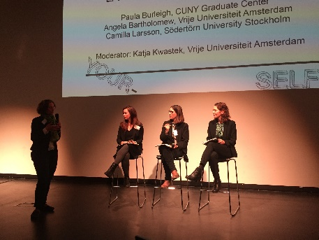
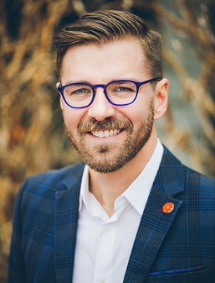
Chad Alligood, curator at Crystal Bridges Museum of American Art, has been named the Virginia Steele Scott Chief Curator of American Art at The Huntington Library, Art Collections, and Botanical Gardens in San Marino, California. After Alligood joined Crystal Bridges in 2013, he organized the exhibition “State of the Art: Discovering American Art Now,” which received the 2015 Excellence in Exhibition Award from the American Alliance of Museums. More recently, he curated “Warhol’s Nature” (2015). He also spearheaded major acquisitions by women artists and artists of color and led the reinstallation of the postwar permanent collection galleries.
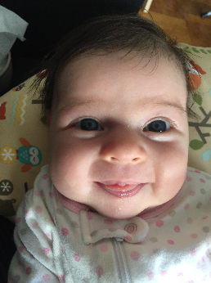
Elizabeth Berkowitz published the article "With All Good Intentions: Jacob Lawrence at the Museum of Modern Art" in the journal Culture, Theory and Critique (January 2017); a review of a recent English translation of Magritte's writings in The Brooklyn Rail (February 2017); and the article "The 1910 Post-Impressionist Exhibition," for the journal BRANCH: Britain, Representation, and Nineteenth-Century History (March 2017). She also welcomed her second daughter Lily Miriam on January 24, 2017.
Paula Burleigh holds a Joan Tisch Teaching Fellowship at the Whitney Museum of American Art, where she was recently promoted to the title of Senior Fellow. She contributed an essay entitled "Sacred Fortresses: The Church of Saint Bernadette of Banlay and the Mechanized Body in Postwar France" to an anthology called Architecture and the Body, Science and Culture, to be published by Routledge in September of 2017. Along with Janna Schoenberger, she presented a paper at Lose Yourself! Symposium on Labyrinthine Exhibitions as Curatorial Model a symposium held at the Stedelijk Museum in February 2017. Additionally, Paula gave a paper in a panel on the Kinetic Imaginary at CAA.
Elizabeth DeRose presented at SECAC in October 2016. Her paper, titled "Editioning as Conceptual Strategy: Alvaro Barrios, Grabados populares," is based on research for her dissertation-in-progress.
Jennifer Favorite published "'We Don't Want Another Vietnam': The Wall, The Mall, History, and Memory in the Vietnam Veterans Memorial Education Center" in the Fall 2016 edition of Public Art Dialogue.
In the fall semester, Joseph Henry organized the international conference “Scales of Visibility in Global Indigenous Art,” with Chris Green and Ian Wallace and with support from the Rewald Endowment and the Graduate Center’s Center for Humanities. The event was designed in collaboration with the Vera List Center for Arts and Politics as part of a longer weekend on contemporary indigenous art. This semester, Joseph presented two papers: “Ambient Spectatorship” at the “Critical Matter of Performance” symposium held in February at the New Museum and in April, he’ll represent the Graduate Center at the IFA-Frick Symposium with a paper titled “Imitation and Crime: Hermann Muthesius and the Surrogate.” This summer, Joseph will travel on a Doctoral Student Research Grant to Germany and Switzerland to conduct preliminary research for his upcoming independent study with Prof. Golan and eventual dissertation work. Next year, he will be a Helena Rubenstein Critical Studies Fellow at the Whitney Independent Study Program.
Cara Jordan successfully defended her dissertation, "Joseph Beuys and Social Sculpture in the United States," under advisor Prof. Harriet Senie in October 2016. She published an article on her research in Seismopolite Journal of Art and Politics and presented at the 2016 CAA annual conference, in addition to invited lectures at the University of Virginia and Zeppelin Universität. She serves as the editor of the Peter Halley Catalogue Raisonné of 1980s Paintings, which will be published by JRP|Ringier in summer 2017. Currently, Cara works as a freelance editor in New York and Berlin, Germany.
Maria Lucca participated in the RSA 2107 Conference international panel, Lying in State: The Effigy in Early Modern Italian Funerary Art ca. 1400-1600. Maria’s paper, Sienese Funeral Effigies: A Case Study in Cross-Cultural Exchange in Central Italy discussed how the diverse style of Sienese effigies—honoring patrons and high-ranking ecclesiastics—illustrates the cross-cultural transfer between Siena and Central Italy. Her talk highlighted Sienese sculptors who assimilated elements derived from ancient Rome and humanist Florence, while retaining their native Sienese artistic traditions. In sum, Maria examined the overall importance of cross-cultural exchange in Sienese tomb design throughout the Italian peninsula.
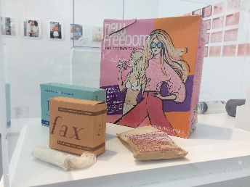
Michelle Millar Fisher has forthcoming: a chapter on Bauhaus toys in an edited volume from Bloomsbury Academic Press; a chapter (and served as co-editor) on a book on collaboration in visual art from Courtauld Books Online; and the exhibition catalogue for MoMA's first fashion and design show in over 70 years, Items: Is Fashion Modern?. She is co-organizing this exhibition and, in April 2017, put together a small show on design for menstruation and reproductive health that will travel to MUCA Roma, Mexico City, in the fall. She will undertake a dissertation completion fellowship as a PEO Scholar in 2017-18.

Meredith Mowder was awarded the Mid-Atlantic Popular and American Culture Association's Ralph Donald Award which recognizes an outstanding paper and presentation delivered at MAPACA's annual conference. Her paper was titled, "Art After Dark: The Rise of Nightclub Performances in Downtown New York, 1978-1988."
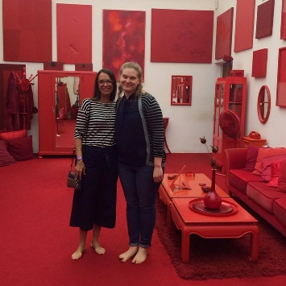
In the summer of 2016, Gillian Sneed won an ERI Knickerbocker Award and a Marian Goodman Travel Grant to conduct dissertation research in Los Angeles and in Brazil. In the Fall, she participated in a panel titled “Cleaning Up New York City in the 1960s and 1970s” as a part of the James Gallery’s exhibition The House of Dust by Alison Knowles; and she gave a talk on the feminist artist Rosemary Mayer as a part of Southfirst Gallery’s exhibition Rosemary Mayer: Conceptual Works & Early Fabric Sculptures, 1969-1973. In the Spring, she presented at the CAA conference in New York and at LASA in Lima, Peru. She also won the Graduate Center's Capelloni Dissertation Fellowship for the 2017-2018 academic year.
Janna Schoenberger successfully defended her dissertation “Ludic Conceptualism: Art and Play in the Netherlands, 1959 to 1975” in November 2016. She presented “Ludic Exhibitions at the Stedelijk Museum: Die Welt als Labyrinth, Bewogen Beweging, and Dylaby” at the Stedelijk Museum symposium, Lose Yourself!, and “The Ersatz Art School and Councils of Councils: Dutch Institutions of Critique in the 1960s” at CAA. In 2016, she supervised undergraduate research at the Rijksmuseum, leading students in independent projects investigating the museum’s collection of 1960s magazines and prints.

ALUMNI NEWS
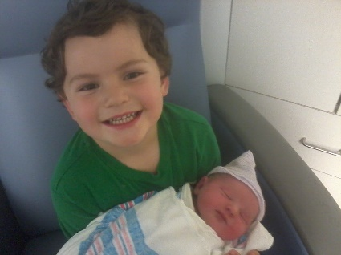
Sarah Archino (2012) was the 2016 recipient of SECAC's William R. Levin Award for Research in the History of Art. She presented on interdisciplinary collaborations at the first Conference on the Liberal Arts in Jackson, MS and CAA, and chaired a session on encouraging students to risk failure at SECAC. Her essay on Duchamp and the American Press is being published by the Duchamp Research Center in Schwerin, Germany. Her daughter, Sadie Ames, was born on March 12, making 4-year-old Hank a big brother.
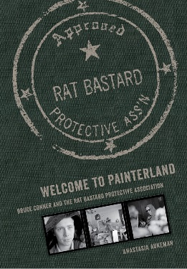
Anastasia Aukeman (2013) was a featured speaker at MoMA and SFMOMA last fall in connection with the exhibition Bruce Conner: It’s All True. She organized the exhibition Rat Bastard Protective Association for The Landing in LA (Fall 2016) and Susan Inglett Gallery in NY (April 29 - June 3, 2017) in conjunction with her recent book, Welcome to Painterland: Bruce Conner and the Rat Bastard Protective Association (Oakland: University of California Press, 2016). In March 2017, she gave a talk at the di Rosa in Napa. In summer 2017, she will appear in conversation with New Yorker editor Deborah Treisman at City Lights Bookstore and participate in the conference “Revisiting the Summer of Love, Rethinking the Counterculture” (Northwestern University and the California Historical Society).
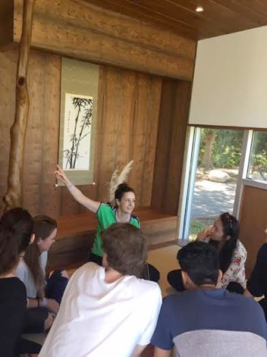
Chelsea Bruner joined the faculty of Ringling College of Art + Design in Sarasota, Florida in the fall of 2015. She is one of seven full-time art historians in the Liberal Arts program, and primarily focuses on the history of design. After fourteen years in New York City, Chelsea is enjoying being back at home in Florida. This February, Chelsea presented “Perfect Vision: Issey Miyake and a Museum of Design in Japan” at the 2017 CAA conference, as part of the session, “Design Museums: The New Wave.”
Annie Dell'Aria (2016) began her position of Assistant Professor of Art History at Miami University in Ohio. She presented a paper, "Between the Moving Image and the Physical Screen: Challenges and Controversies in Moving Image-Based Public Art," at CAA. This summer she will participate in the NEH Summer Institute on Space, Place, and the Humanities at Northeastern University.
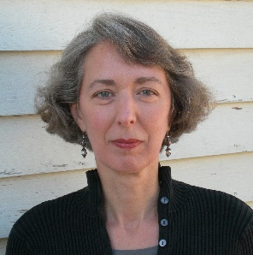
Martha Buskirk recently completed a fall 2016 fellowship semester at the Clark Art Institute, where she was working on a new book addressing intersections between artistic authorship and intellectual property. Two essays on contemporary art and the museum appeared in newly published anthologies: “Museum Relations,” in Re-envisioning the Contemporary Art Canon: Perspectives in a Global World, and “The Museum as Producer,” in Now—Tomorrow—Flux: An Anthology on the Museum of Contemporary Art. Forthcoming publications include articles for the Cornell Journal of Law and Public Policy, Acoustic Space Journal, and Kunstforum. In fall 2017 she will participate in “The Readymade Century,” in Berlin.
Beth Harris (1997) and Steven Zucker (1997), co-founders of Smarthistory, have recently received awards from the following organizations to support Smarthistory: Andrew W. Mellon Foundation, Sameul H. Kress Foundation, National Endowment for the Humanities. The Mellon grant allowed them to award a one-year postdoc to a new GC alum, Dr. Naraelle Hohensee as well to expand content. The Kress grant is to support conservation content on Smarthistory. The NEH grant is focused on Endangered Cultural Heritage.
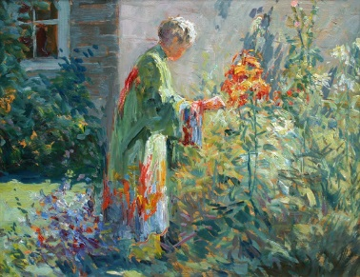
Susan G. Larkin was guest curator of Matilda Browne: Idylls of Farm and Garden, held at the Florence Griswold Museum in Old Lyme, CT, from Feb. 10 to May 28, 2017. In a career that spanned five decades, Browne (1869-1947) exhibited her work across the United States, winning prestigious awards and critical praise. By the time of her death, however, her sparkling images of gardens and Barbizon-influenced depictions of farm animals had fallen out of favor. The exhibition in Old Lyme is her first monographic show in a museum. A fully illustrated catalogue is available.
Valerie Ann Leeds (2000) served as the guest curator and author for Paul Moro: A Painter's Journey, an exhibition and publication sponsored by the Newington-Cropsey Foundation. Following its presentation at the Newington-Cropsey Foundation, the exhibition travels to the Cahoon Museum of American Art. She was also a contributor to Works on Paper From the Collection of the Sheldon Museum of Art, published by the University of Nebraska Press, and presented a talk on Robert Henri and his engagement with Spain as part of the Clyde Burroughs Lecture Series at the Scarab Club in Detroit.

Jill Marie Lord is an adjunct professor in the School of Architecture, University of Virginia. She is teaching architectural history classes in the History of Modern Architecture and American Architecture.
Tetsuya Oshima (2008) has been an associate professor at Hiroshima University in Japan since 2015. He contributed an article on Jackson Pollock's cut-outs to the catalogue of the exhibition "The Figurative Pollock" held at the Kunstmuseum Basel in 2016-17.
Herbert R. Hartel, Jr. (2002) has contributed exhibition reviews to Art in America and the International Review of African American Art. He also contributed essays on the Harlem Renaissance and William H. Johnson to the reference source The Bible and Its Reception in the Visual Arts (De Gruyter, 2017). His essay “Raymond Jonson: A Southwestern Modernist Alone on the Prairies" (Chapter Four) was published in Cynthia Fowler, ed., Locating American Art (Ashgate, 2016).
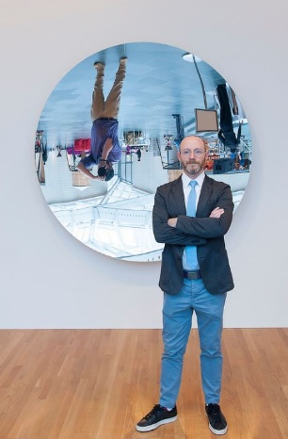
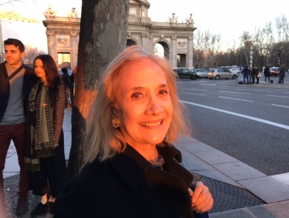
In the last year Julia Herzberg was a visiting professor at The Institute of Art (Viña del Mar) at Pontifical Catholic University of Valparaiso, Chile. Recent publications include: “Past – Present: Conversations with María Lau and Katarina Wong,” in Circles and Circuits: Chinese Caribbean Art. Eds. Alexandra Chang and Steve Wong. Durham: Duke University Press, 2017 (forthcoming) for the exhibition of the same name that will open at the Chinese American Museum in Los Angeles as part of "Pacific Standard Time: LA/LA." “Conversación entre Claudio Correa y Julia P. Herzberg” in Libertad, Igualdad, Fatalidad. Santiago: National Museum of Fine Arts, 2016. (pp. 6 – 7) (Co-essayists Gerardo Mosquera, Alexis Talas, Julia Herzberg) and “A Conversation with María Elena González: A Trajectory of Sound,” in María Elena González: Tree Talk Series. Ljubljana, Slovenia: International Center of Graphic Arts, 2016 (pp. 42-52). (Bilingual catalogue in Slovenian and English for the Grand Prix Winner of the 30th Biennial of Graphic Arts) (Editor and Essayist Bozidar Zrinski). She is a contributing editor for Arte al Dia where she wrote a short article, “The MET Breuer,” Arte al Día International 151 (2016): 3-7, and “Leandro Katz in Conversation with Julia P. Herzberg,” (Feb. 2017).
In February Marshall Price opened the exhibition Nina Chanel Abney: Royal Flush at the Nasher Museum at Duke University, where he is the Nancy Hanks Curator of Modern and Contemporary Art. The exhibition is accompanied by a catalogue that will be available in May 2017. Marshall is also adjunct faculty in the Department of Art, Art History and Visual Studies at Duke where he taught a new course this spring, The History and Theory of Curatorial Practice. In April, Marshall received the Distinguished Alumni Award from the Penn State College of Arts and Architecture, where he received his Master’s degree.
Britany Salsbury (2015) began as Associate Curator of Prints and Drawings at the Milwaukee Art Museum in February 2017. At the museum, she is responsible for a recent gift of one of the largest and most comprehensive collections of works on paper by the French artist Jules Chéret, which will be the focus of an exhibition and publication tentatively scheduled for 2019. Before Milwaukee, Britany was the Andrew W. Mellon Curatorial Fellow in the Department of Prints, Drawings, and Photographs at the RISD Museum, where she organized the exhibition and publication Altered States: Etching in 19th-Century Paris, set to open in June 2017.
Karen Shelby (2008) taught a course on art and World War I at KASK (School of Arts of University College Ghent) and led a study abroad program to Flanders, Belgium for the M.A. Program in Arts Administration at Baruch College. She published Belgian Museums of the Great War: Politics, Memory, and Commerce (Routledge; the Routledge Research in Museum Studies’ series), “Nationalism and Commemoration in Belgian War Cemeteries,” RIHA (Journal of the International Association of Research Institutions in the History of Art), and “Westfront Nieuwpoort: The (Collected) Memory of the Belgian Front” for Beyond Flanders Fields, Christophe Declercq and Felicity Rash, Eds. (Palgrave MacMillan).
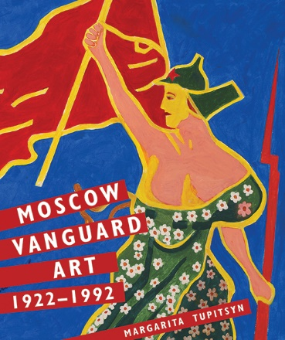
Margarita Tupitsyn is the author and co-editor of the two new books, Moscow Vanguard: 1922-1992, Yale University Press, and Anti-Shows: APTART, 1982-1984, Afterall. In 2017 Tupitsyn also published several articles "From Black Square to Room Square," Journal of Visual Culture, Vol. 16, no. 1, April 2017, pp. 20-27, "An Empty Action is Not for a Movie Camera," post.at.moma.org, “Descending toward Socialist Realism,” and “Boris Mikhailov” in, ed. Michael Baumgartner, Kathleen Bühler, Nina Zimmer, Kunstmuseum Bern and Zentrum Paul Klee.
Midori Yamamura (2012) served as a consultant scholar for Hirshhorn Museum and Sculpture Garden’s Yayoi Kusama: Infinity Mirrors exhibition and has been invited to various venues to speak about Kusama. Currently a Japan Society for the Promotion of Science Postdoctoral Fellow writing her second book, Japanese Contemporary Art Since 1989: Emergence of the Local in the Age of Globalization (Reaktion Books; University of Chicago Press), she traveled extensively in Japan. Her short-form writings on this topic appeared in CAA.Review and Art in America. She received a Tate Asia Pacific Research Center Travel Fellowship to attend a post-1989 Asian Art Conference in Korea.

Departmental Workshops 2016-2017
Fall 2016
Sept. 20: “Navigating the Art History Program” with Professor Manthorne
Oct. 28: “The Oral Exam: Strategies for Success” with Professor Sund
Nov. 1: “Museum Careers” with Art History program alumnae Kim Orcutt and Shannon Vittoria

Spring 2017
Feb 24: “Choosing and Working with an Advisor” with Professor Bishop
March 7: “Balancing Work and Family Life” with Professor Wunder and Art History program alumnae Mary Brown and Karen Shelby
March 31: “Alumni-Student Mixer!” with Professor Kousser and Art History program alumni
May 9: “Art History Program Book Party” celebrating recent books by Faculty, Students, and Alumni

Rewald Seminars 2016-2017

Fall 2016
Sept 13 - Anthony White, “Machine Folk: Art, Décor and Theatre in the Work of Fortunato Depero"
Sept 27 - Maria Loh, "Titian: The Painter as Anti-Pygmalion"
Oct 18 - Maria Stavrinaki, “Prehistory at the atomic age: Georges Bataille and the art of the 1950s”
Oct 25 - Chris Richards, “Think Pink (and Black): Sartorial Incidences in Accra, Ghana”
Nov 8 - Renato Anelli, “Lina Bo Bardi's civilization of survival: modern design in poverty”
Nov 15 - Iftikhar Dadi, “Calligraphic Abstraction: Anwar Jalal Shemza”
Nov 29 - Meredith Gamer, "Seeing Death Properly: Exhibitions and Executions in Eighteenth-Century London”
Dec 6 - Pamela M. Lee, "Pattern Recognition circa 1947"

Spring 2017
February 7 - Amanda Wunder, “Baroque Seville: Sacred Art in a Century of Crisis”
February 21 - Thomas Elsaesser, “Attention and Distraction: Distribution of the Senses”
March 14 - Lisa Farrington, “The World Before Racism: Blacks in Western Art”
April 4 - Lucia Allais, “From Perimeter to Perimeter: Museums, Monuments and the Humanization of War in the Interwar”
April 25 - Edit András, “Flagging the Nation in Post-Socialist Countries through the Artist’s Eyes”

DONATION BOX

To make your tax-deductible gift to the art history department please mail a check payable to the “Graduate Center Foundation,” 365 Fifth Avenue, Suite 8204, New York, NY 10016. Please write “Art History” on the memo line. You may also visit us online https://community.gc.cuny.edu/ProgramGifts selecting “Art History” under the “Designation” menu.

First select the Amount of your gift.
Next, at the Designation menu, select “Art History.”
Complete the Billing and Payment Information sections.
Click “Donate Now” to complete.

You will receive an immediate e-mail verifying your gift. A tax receipt (including the amount and the fund designation) will follow in the mail to the address you provide. Please call the Graduate Center's Development Office if you require any assistance or would like to make your gift over the phone: 212-817-8670.
DISSERTATIONS IN PROGRESS 2016-2017
Abbaspour, Mitra, “Defining the Present, Archiving the Past: Three Histories of Middle Eastern Photography” (C. Bishop)

Ackerman, Emily, "Selling Dreams: Nickolas Muray and Commercial Photography in the United States, 1920-1965" (A. Pelizzari)
Aguilar, Margarita, “Traditions and Transformations in the Work of Adal: Surrealism, El Sainete, and Spanglish” (K. Manthorne)

Barrow, Theodore, “ ‘Gilded Tropics’: Winslow Homer and John Singer Sargent in Florida, 1885-1917” (J. Sund)

Bellucci, Matteo, “Pietro Dura/Parchin Kari: Mediations between Florence and Mughal India” (M. Aitken)
Berkowitz, Elizabeth, "Bloomsbury's Byzantium and the Writing of Modern Art" (R. Long)

Bucilla, Drew, “Europ: Expanded Cinema, Projection and the Film Co-op in Western Europe, 1966-1979” (D. Joselit)

Bucarelli, Viviana, “Awe in Quietude: Transcendentalist Magic Realism” (E. Braun)

Burleigh, Paula, “The Labyrinth, the Cave, and the Monolith: Archaic Impulses in Utopian Projects in Europe, 1947-1972” (R. Golan)

Campbell, Andrianna, "Norman Lewis: Linearity, Pedagogy and Activism in his Abstract Expressionism, 1946-1964" (D. Joselit)
Cappetta, Andrew, “Pop/Art: The Birth of Underground Music and the British Art School, 1960-1980" (C. Bishop)
Cardon, Alexandra, “Circa 1700: Royal Retreats, Academic Unrest and the Roots of Rococo” (J. Sund)

Choi, Sooran, "The South Korean Avant-garde, 1967-1992: Subterfuge as Radical Agency" (M. Hadler)

DeRose, Elizabeth, “Defying Graphic Tradition: Printmaking Strategies of Latin American Conceptualists (1963-1984)” (A. Indych-López)

Donato, Elizabeth, “A Series of Acts that Disappear: The Valparaíso School's Fleeting Architectures, 1952-1982” (A. Indych-López)

Dosch, Mya, “Creating 1968: Art, Architecture, and the Memory of the Mexican Student Movement” (A. Indych-López)
Edwards, Randall, “Beyond Land Art: Site, Body, and Self in the Work of Dennis Oppenheim, 1967-75” (H. Senie)
Favorite, Jennifer, “Museum Additions at U.S. War Memorials and the Reinterpretation of National History" (H. Senie)

Farzin, Media, “Theater, Artifice, and Opacity: Guy de Cointet and 1970s Performance” (S. Wilson)

Fisher, Michelle Millar, “Nothing is Transmissible but Thought: Le Corbusier’s Radiant City in Diaspora” (K. Murphy)

Gontar, Cybèle, “José Francisco Xavier de Salazar y Mendoza and Jacques Guillaume Lucien Amans: Portraiture, Identity, and Plantation Society in New Orleans, 1790-1890.” (K. Manthorne)

Grayson, Saisha, “Cellist, Catalyst, Collaborator: The Work of Charlotte Moorman, 1963-1980” (C. Bishop)

Haines, Chelsea, “Staging the Modern, Building the Nation: Israeli Exhibitions, 1948-1965” (R. Golan)

Harris, Leila, “Labor and the Picturesque: Photography, Propaganda, and the Tea Industry in Colonial India and Sri Lanka, 1880-1914” (A. Pelizzari)

Hawley, Elizabeth S., "Imaging the Indian/Imagining the Indian: Modern Art and Native Tradition in Santa Fe, 1909-1931" (K. Manthorne)

Heung, Elsie, “Women's Suffrage in American Art: Recovering Forgotten Contexts, 1900-1920” (G. Levin)

Huber, Stephanie, “Cultural Predicaments: Neorealism in The Netherlands 1927–1945” (E. Braun)

Isotani, Yusuke, “The Quest for Identity in French Photography: The History of Arts et Métiers Graphiques (1927-1939)” (R. Golan)

Kaplan, Lauren, “Crossing the Atlantic: Italians in Argentina, 1880-1930" (E. Braun)

Karras, Olga Zaferatos, “Constructing Greek Genre Painting, Visualizing National Identity, 1850-1900” (A. Pelizzari)

Kogut, Gabriela, “Fictions of the Real: Direct Experience and Mediation in Postwar American Art and Visual Culture” (M. Hadler)

Lapin Dardashti, Abigail, “Politics, Religion, and Modernity in Transregional Afro-Brazilian Art, 1962-1988” (A. Indych-López)

Lehman, Bree, “Ancestors and Heirlooms: The Reception, Collection, and Display of Early American Portraiture, 1876-1941” (K. Manthorne)

Lucca, Maria, “Renaissance Siena as a Case Study of Cross-Cultural Exchange in Central Italy” (J. Saslow)

Martinez, Trinity, “The Rise and Fall of the Civilized Centaur in Italian Renaissance Art” (J. Saslow)

McCollum, Christina, “'Exhibitions of Outsider Art Since 1947” (R. Golan)

McGraw, Eva, "Xanthus Smith: Marine Painting and Nationhood" (K. Manthorne)

McMichael, Alice Lynn, “Rising Above the Faithful: Monumental Ceiling Crosses in Byzantine Cappadocia” (J. Ball)

Mills, Sarah, “Without A Blueprint: Weaving and Industrial Design in the United States, 1938-1956” (R. Bletter)

Mowder, Meredith, “Art after Dark: Performance in Downtown New York, 1978-1988” (C. Bishop)

Musteata, Natalie, “From Radicality to Romanticism: The Institutionalization of the Artist as Curator, 1970-2010” (C. Bishop)

Nakagawa, Ikuyo, “Negotiating Boundaries: Nationalism and Internationalism in the Art of Tsuguharu Foujita” (E. Braun)

Palmer, Daniel S., “The Integration of Art, Architecture, and Identity: Alfred Kasatner, Louis Kahn, and Ben Shahn at the Jersey Homesteads” (K. Murphy)

Park, Haeyun, “Electronic Esperanto: Trans-Pacific Development of Video Art, 1969-1991” (D. Joselit)

Partridge, Joy, “Visualizing Knowledge in the Illuminated Manuscripts of the Breviari d'amor” (C. Hahn)

Perucic, Nadia, “From Fiction to Fact: The Need to Document in Post-Yugoslav Visual Art from 1991 to the Present” (C. Bishop)

Pistell, Gillian, “Ray Johnson: Artist as Archivist” (M. Hadler)

Rivera Fellah, Nadiah, “Stills of Passage: Photography and Migration in the U.S.-Mexico Borderlands, 1978-1992” (A. Indych-López)
Roje, Natasha, “After Abstract Expressionism: Revisiting the ‘Death of Painting’ Problematic” (D. Joselit)
Rosati, Lauren, "Mechanical Kingdoms: Sound Technologies and the Avant-Garde, 1930-1933" (E. Braun)
Siefert, Rebecca, “The Work of Lauretta Vinciarelli in Context: Artist, Teacher, Theorist” (M. Hadler)
Simpson, Nicole, “Prints on Display: Exhibitions of Engraving and Etching in England, 1780-1858” (K. Manthorne)

Slodounik, Aaron, “The Painter and his Poets: Paul Gauguin and Interartistic Exchange” (J. Sund)

Sneed, Gillian, "Gendered Subjectivity and Resistance: Brazilian Women's Performance-for-Camera, 1974-1985" (A. Indych-López)

Stewart, Danielle, "Framing the City: Photography and the Construction of São Paulo (1930-1955)” (A. Indych-López)
Steverlynck, María-Laura, “The School of the South Experiment: The Pedagogy and Legacy of a New World Modernism” (A. Indych-López)
Stutterheim, Sydney, “Accomplices in Art: 1971-1987” (D. Joselit)
Stritzler, Nina, “Architecture at MoMA, 1929-1949: Defining a Curatorial Practice” (R. Bletter)

Tifentale, Alise, "The ‘Olympiad of Photography’: The International Federation of Photographic Art, 1950-1965" (S. Wilson)
Walkiewicz, Alice J., “From the 'Song of the Shirt' to the Call to Organize: The Seamstress in Late-19th-Century Art in Europe and the United States” (J. Sund)
Wasielewski, Amanda, “Krakers in the Virtual City: From Squats to Net Art in Amsterdam, 1980-2000” (D. Joselit)
Weaver, Alison, “The Beuys Effect: Joseph Beuys’ Reception in the United States” (S. Wilson)

Wei, Chu-Chiun, “Globalism and Identity in Taiwanese Contemporary Art, 1978-2009” (C. Bishop)

Weintraub, Sara, “From Design to Completion: The Transformation of U.S. War Memorials on the National Mall” (H. Senie)

Xydas, Fotini, “Pissarro: The Works on Paper” (J. Sund)

DISSERTATIONS DEFENDED 2016-2017
Caplan, Lindsay, “ ‘Open Works’: Between the Programmed and the Free, Art in Italy from 1962 to 1972” (R. Golan)
Clark, Marci Muhlestein, "I.M. Pei, William Zeckendorf, and the Architecture of Urban Renewal" (J. Maciuika)
Gerspacher, Arnaud, “Posthumanist Animals in Art: France and Belgium 1972-87” (C. Bishop)
Jordan, Cara, "Joseph Beuys and Social Sculpture in the United States" (H. Senie)
Hallman, Lee, “On London Ground: The Landscape Paintings of Frank Auerbach and Leon Kossoff” (E. Braun)
Laux, Barbara M., "Claude III Audran, Modern Ornemaniste of the Rococo Style" (P. Mainardi)
McKelligan Hernández, Alberto, “Mónica Mayer: Translocality and the Development of Feminist Art in Contemporary Mexico” (A. Indych-López)
Raffel, Amy, "Merchandise, Mass Media, and Accessibility: Keith Haring’s Pop Shop” (S. Wilson)
Saunders, Beth, “Developing Italy: Photography and National Identity during the Risorgimento, 1839-1859" (A. Pelizzari)
Scott, Hallie, “Communicationists and Un-Artists: Pedagogical Experiments in California, 1966-1974” (C. Bishop)
Schoenberger, Janna, “Ludic Conceptualism: Art and Play in the Netherlands, 1959 to 1975” (C. Bishop)
Vangen, Michelle, “Left and Right: Politics and Images of Motherhood in Weimar Germany” (R. Long)
Thompson, Whitney, “Foreign-born Artists Making ‘American’ Pictures: The Immigrant Experience and the Art of the United States, 1819-1893” (K. Manthorne)

